Supplemental figures
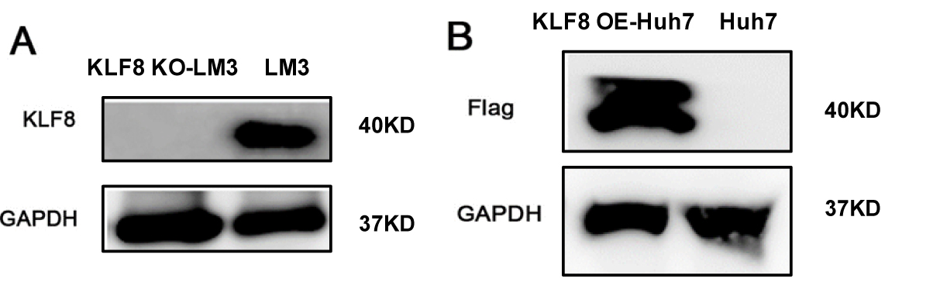
SF1. (A) Western blot analysis of KLF8 in KLF8^{KO}-LM3 or LM3 cells.
(B) Western blot analysis of KLF8 in Huh-7 cells transfecting KLF8 overexpressing lentivirus or control lentivirus using an anti-flag antibody.

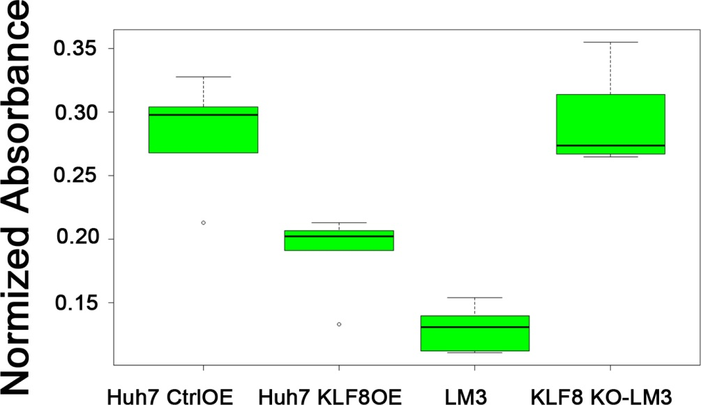
SF2. Cell proliferation assay detected by CCK8 assay in Ctrl^{OE} Huh-7 / KLF8^{OE} Huh-7 cells and LM3 / KLF8^{KO} LM3 cells.

Supplemental table 1. Genes differentially expressed as well as H3K27 acetylation changed between KLF8^{KO}-LM3 and LM3 cells.
Supplemental table 2. Primers for ChIP-QPCR.

